Gatekeeping or Gate Opening?

Tot Foster recounts her experiences of a fascinating conference that addressed the problem of relying too heavily of “usual suspects’ who act as gatekeepers and who may limit access to certain groups. No group is ‘Hard to Reach”: The real problem is lack of effort to access and include them

On 8th December I went to a one-day conference: ‘Overcoming Reliance on Gatekeepers:
Addressing Racial Equity Through Meaningful Partnerships and Collaboration with Black and Minority Ethnic Communities at a Local Level’. This was organised by Dr Fidele Mutwarasibo, the Director of the Centre for Voluntary Sector Leadership at the Open University.
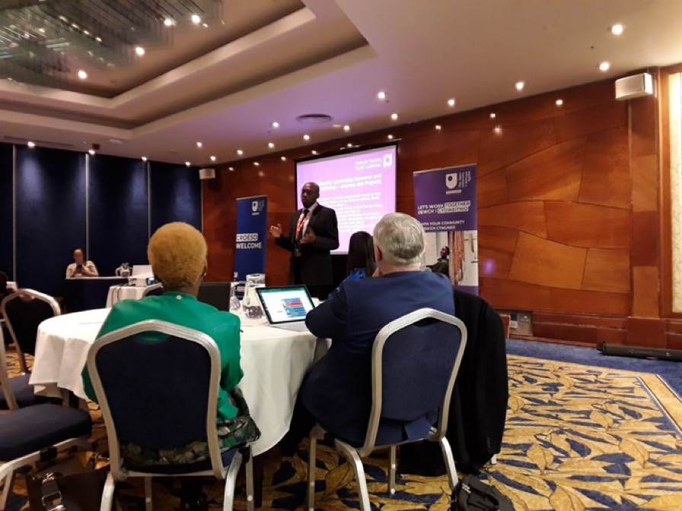
Fidele opens the conference

The event explored how projects overcome one particular barrier to participation in local, black, Asian and minority ethnic community organisations; the actions of ‘gatekeepers’ rather than ‘bridge-builders’. As Fidele and several other speakers emphasised; no group is ‘hard to reach’ – the real problem is not making enough effort to access or include them – and gatekeeping makes that access more difficult. Yaina Samuels Founder of NuHi and a Training and Project Development Officer at Adferiad Recovery advocated for the power of one-to- one conversation: ‘You want to build up trust… then everything else will come’.

One project – Covid Chronicles from the Margins - really resonated with the work that we do at Bristol University our Connecting through Cultur e project. Covid Chronicles is a collaboration between the Open University and SASS - Swansea Asylum Seeker Support and numerous other asylum-seeker and refugee support groups. Marie Gillespie and Tom Cheesman spoke about how they wanted to find a way of sharing creative responses to living as an asylum seeker or refugee in the pandemic; connecting people through their smartphones. ‘Cov19: Chronicles from the Margins’ has received many and varied artworks; photos, paintings, poems, videos. These are presented on a public facing website cum gallery https://cov19chronicles.com/the-project/. And what started as local to Swansea, including digital skills development, photography workshops and training in social research for asylum-seekers and refugees, grew steadily to become truly international.

The project acknowledges and draws on the huge expertise held by asylum seekers and refugees –in international migration, international law, solidarity cultures and local volunteer and community support. In academic terms it’s about the co-production of knowledge and about the lived experiences of those with precarious migration status – especially during and now as we emerge from the pandemic. On another level it offers connections between those who share painful experiences, and those of us who haven’t even been close to those experiences - a compassionate but stark window onto what’s going on for individuals living in our communities; as Marie described it ‘a collective creative mobilisation of everyday experience’.

It was interesting to hear the very varied ways in which ideas about and experience of gatekeepers were represented – from Fidele’s insights into the pitfalls of community leadership, through to local government anti-racism policies and practices that, in the past at least, was better at writing reports than implementing recommendations. Another big issue discussed was overreliance on consulting with large organisations rather than connecting at the local grassroots level. Also debated were the rigorous ethics procedures at the Open University that are necessary and have to be carefully negotiated so as not to put barriers in the way of collaborating with local, grassroots organisations and to being able to be agile and responsive.

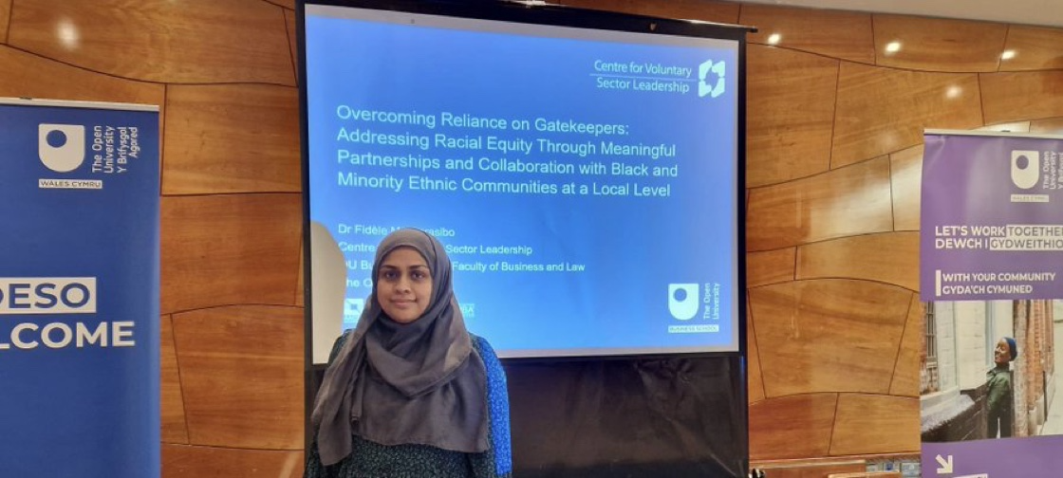

Image 2: Dr Fatiha Ali from Ethnic Youth Support Team (EYST) presents

But what all the speakers had in common was the importance of getting at lived experience, involving and listening to what people say about their daily encounters, practices and emotions, and then building that understanding into projects and services. Charlotte Amoss from Cardiff Council spoke of ‘collaborative solutions…locally owned’.

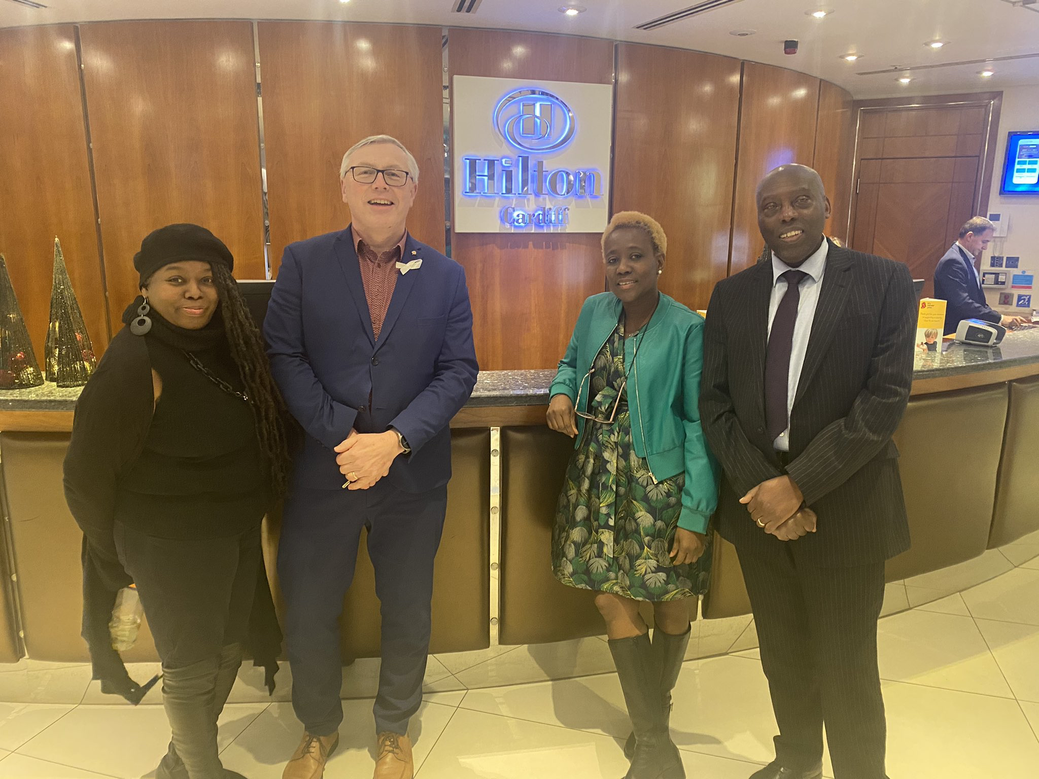
Fidele with conference delegates

At Connecting through Culture our co-research is based on a lifecourse approach; and empowering the participation of minoritised older people in tech innovation; a sphere which has tended to overlook their experiences. It does feel that, 18 months in, the project has been breaking down some barriers.

Leaving the event, I felt this was a day where real insights were shared and great connections made.

Tot Foster completed her PhD at the Open University two years ago. Since then she has been working with older people who identify as minoritised on the project Connecting through Culture As We Age at Bristol University https://connectingthroughcultureasweage.info/, and also as a freelance researcher at the Open University on projects around the digitalisation of the voluntary sector and mobilising older people's skills for community benefit.

