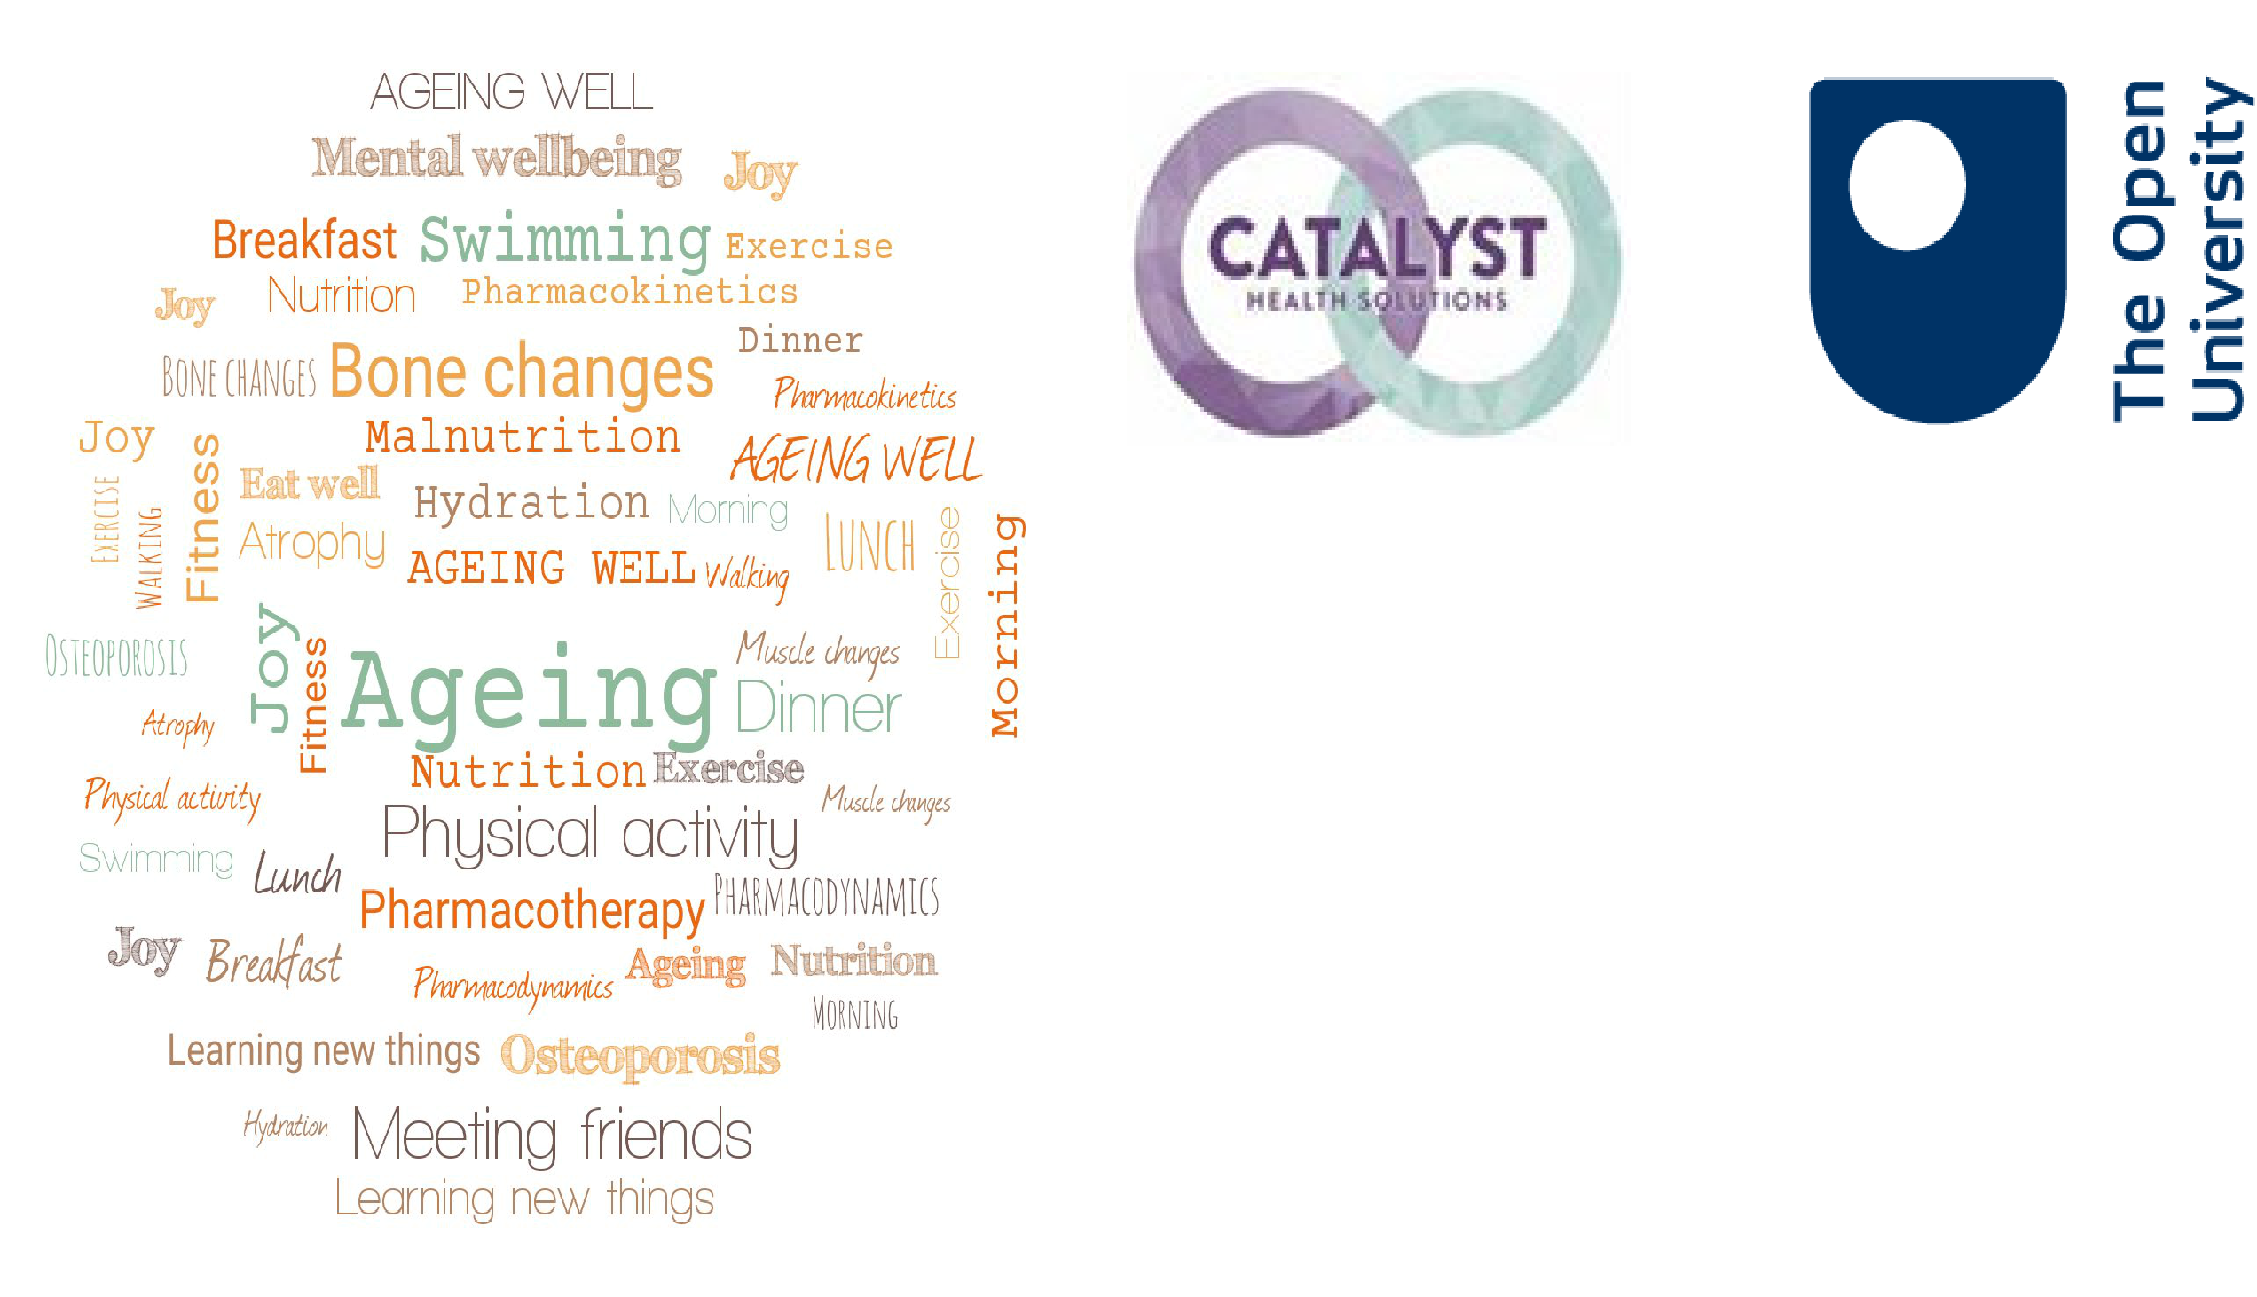

Ageing Well Public Talk Series 21/22: Talk 7. Pharmacotherapy while ageing. Jitka Vseteckova & Sonal Mehta

Today’s talk

- The world population is rapidly ageing & we are all ageing since the day we are born.

- Physical and psychological/cognitive decline that happens at different speeds for different individuals.

- Ageing processes are in general very difficult to predict.

- Genetic predispositions we may need to take into account regarding the overall ageing the process is also co-defined by what we actually do about it.

- USE IT OR LOSE IT - in other words, both cognitive and physical stimulation while ageing, help to preserve cognitive and physical functions we don’t want to lose. Especially during COVID-19 times.

- The Five Pillars of Ageing Well

- All the way through the ‘Ageing Well’ talks we explore how using this knowledge might facilitate self-management, become partners in our care and delay the ageing processes for as much as we can.
- The emphasis of the ‘Ageing Well’ series is on optimizing cognitive and physical well-being, physiological ageing, and self-management. To a lesser extent, on pathological processes while ageing.
- Promoting physical activity, social activity, networking, learning and healthy lifestyle
- Building bridges

Pharmacotherapy while ageing

- Changes related to physiological ageing (muscle, metabolism, kidney, liver)
- Comorbidity / poly-morbidity resulting in poly-pharmacy
- Dehydration
- Malnutrition/undernutrition
- Pharmacokinetics
- Pharmacodynamics
- Polypharmacy & drug interaction & severe drug side effects
- Exercise & Five Pillars of Ageing Well
- THE LESS TIME THE DRUG STAYS IN THE BODY THE BETTER

Biology & ageing

- Mechanisms of changes in
- basal metabolism during ageing. A considerable number of physiological functions are known to show a gradual decline with increasing age
- Muscle mass and total body water are reduced, which can affect pharmacokinetics, especially of hydrophilic drugs- water soluble drugs
- Conversely, body fat increases from 20 to 40% with age, affecting absorption and metabolism especially of lipophilic drugs – fat soluble drugs

- Age-related CARDIO-VASCULAR CHANGES decrease in the overall blood flow – heart rate, heart function, flexibility of vessels and arteries
- LOWER HEART RATE AT REST
- Decrease in kidney function and liver blood flow
- As a consequence, drug clearance decreases
- DEHYDRATION & LACK OF EXERCISE
- Many of the effects of aging on the heart and blood vessels can be reduced, slowed down by regular exercise
- Helps people maintain cardiovascular fitness as well as muscular fitness as they age.
- EXERCISE is beneficial regardless of the age at which it is started.
- Dehydration

- Impact of ageing on the drug journey and its action

- Drug journey

Drug absorption

Ageing may slow down the rate at the which drugs are absorbed, but it is rarely considered clinically significant

Drug distribution

- Decreased muscle mass and dehydration leads to higher concentration of water soluble drugs for a given dose
- Lipophillic drugs concentrate in adipose tissue and the brain. Drugs are slower to clear from fatty tissue – accumulation more likely, CNS effects
- Certain drugs are highly protein bound. Liver damage and malnourishment lead to lower circulation proteins and increase in concentration of free drug
- Blood flow to tissues and organs and active uptake of drugs into tissues may also be influenced by ageing.
- The blood-brain barrier may be more permeable as we age

Drug metabolism

- The liver is the major organ responsible for drug metabolism
- Small amount of age-related decline due to reduced hepatic volume and reduced activity of certain hepatic enzymes
- Rarely significant in the absence of liver disease
- Age-related decreases in hepatic blood flow can decrease the metabolism of drugs with a high first pass metabolism
- Ability of the liver to withstand stress decreases – increased injury due to hepatotoxic medicines
- Some drugs have the ability to induce or inhibit enzymes
- Liver function is not easily measurable and clinical significance can be hard to determine

Drug elimination

- Excretion via the kidneys is the most significant age related change – predictable and measurable
- Reduction in rate of clearance leads to accumulation – can happen very slowly and signs of toxicity may take a while to appear
- Certain drugs rely on good renal functioning to exert their effect
- Some drugs are nephrotoxic, and the overall risks and benefits may need balancing
- Regular blood tests support decision making on dose and appropriateness
- Older people are at a higher risk of acute kidney injury – occurs quickly but can be managed if identified early. Causes can include dehydration, acute illness, infection, drug interactions

Pharmacodynamics

- Drug action in the body is affected by receptor binding, post receptor effects, and chemical interactions, residence time
- Pharmacological effect can be therapeutic or undesirable (side effects and drug interactions)
- Homeostatic changes associated with ageing can be manageable until the introduction of a medicine
- Ageing and polypharmacy increases the risk of adverse drug reactions (ADRs) and exacerbations of chronic conditions
- The consequences are more serious in older people – ADRs account for 5-17% of hospital admissions
- Balancing the risks and benefits of prescribing in the older population is an art not a science!

STANDING UP / SITTING DOWN

- Raising up principle - STRAIGHTENING YOUR SPINE
- Proprioception – feeling different parts of your feet on the floor
- Slightly pressing the inner side of your foot to the floor
- Stretching your toes
- Pushing yourselves away from the ground
- Moving head or arms should not necessarily change the way we stand

Drug related problems in older adults

- Dehydration
- Overuse – polypharmacy – may lead to cumulative effect – TOXICITY (brain, kidneys,
- CV system, liver)
- Inappropriate prescribing (inappropriate prescribing can be defined as prescribing drugs whose use should be avoided because their risk outweighs their potential benefit) - may lead to cumulative effect – TOXICITY (brain, kidneys, CV system, liver)
- Underuse or omission – may not get you treated for the specific condition

- It doesn’t work!!! – the same drug and the same amount of it can take longer to take its effect when we are older…wait for it… don’t take another pill – TOXICITY (brain, kidneys, CV system, liver)
- Diuretics
- A study showed that 25% of the adverse drug reactions reported in an older adult population were related to diuretic therapy, and all those admitted to hospital with medication-related falls were on diuretics
- Dehydration of as little as 2% of total body water can result in a significant impairment in physical, visuomotor, psychomotor and cognitive performances

Drug related effects in the older adults

- Analgesia & increased sedation
- Decreased BP, decreased heart rate
- Vasoconstriction / vasodilatation – blood circulation not ideal
- More regular blood tests required by the GP

Side effects

- Psychomotor dysfunction, confusion
- Sedation, slowed reaction time & LACK OF EXERCISE
- Dizziness, worsened coordination
- Massively increased risk of falls!!!!!

Accumulation of age related changes results

- Drugs take longer to act and stay for longer (2– 3 times)
- Drugs accumulation & drug to drug interaction
- Increased sedation effect
- Increased risk of falls and fractures
- Cognitive dysfunction
- Dependence – withdrawal syndrome
- Limited mobility, limited
- Independence, limited engagement as cognitive functions and/or attention span may be impaired
- Adding DEHYDRATION and LACK OF EXERCISE

Kidney and age related changes

- Irreversible structural and functional changes
- Loss of renal mass due to glomerular loss
- Ability to secrete potassium and excrete hydrogen is impaired
- Reduction in renal blood flow
- Clearance in the aged kidney is also reduced
- These changes impair the ability of the kidney to control water and electrolyte balance, predisposing to dehydration and electrolyte abnormalities, particularly in situations of physiological stress.

Hormonal changes associated with ageing

- Affect fluid and electrolyte homeostasis electrolyte abnormalities usually caused by loss of bodily fluids & dehydration & use of diuretics (symptoms include irregular heartbeat, fatigue, lethargy, nausea, diarrhoea) – can easily lead to falls
- Antidiuretic hormone ADH - in older adults there is loss of the nocturnal rise in ADH, high prevalence of nocturia

- The thirst response while ageing
- Feel less thirsty
- Is blunted and we may forget to drink or not remember whether we drank…
- Spontaneous consumption of fluids decreases
- Extreme vulnerability to dehydration in a state of physiological stress

Personalised Care

- Water soluble drugs/Lipophillic drugs – dosing & frequency
- Regular blood tests & medication reviews to determine ongoing need, efficacy, and potential harm
- Combination of factors to consider – physiology, multimorbidity, polypharmacy
- Heath status can change quickly - symptom relief & quality of life v. prevention
- Practical issues – dexterity, sight, cognition, swallow, housebound, complex regimens, adherence
- Knowledge of ageing and health behaviours are growing
- Lack of evidence for many treatments in older people with multimorbidity
- Self management & shared decision making
- Medication review with a pharmacist

What we need to keep an eye on as we age

Alcohol

- Very little research has been done, and there are some particular problems for the older person.
- Health problems in older age can make us more susceptible to alcohol and can interfere with the effectiveness of many medicines. Check with your doctor about whether it is safe for you to drink with your particular health problem or medication.
- Hidden dehydration
- Drinking too much can damage many parts of the body and increase the risk of health problems including: Stomach lining – ulcers or bleeding; Liver – cirrhosis; Cancer – mouth
- Malnutrition - alcohol has calories but can not provide the essential nutrients a balanced varied diet provides to keep us healthy.
- Excessive alcohol intake can also affect mental health including increasing anxiety, depression, confusion.
- Excessive alcohol intake is toxic to brain cells, and alcohol abuse leads to memory loss. Over time, alcohol abuse may also increase the risk of dementia.

Dehydration

- Ageing produces a decrease in our thirst sensation, so it is easy for dehydration to go unnoticed. So, as we age, it is especially important to drink plenty of water and other non-alcoholic beverages.
- Early signs of dehydration include dizziness, tiredness, headaches, drowsiness, memory loss, and other symptoms that look like dementia.
- Long-term mild dehydration increases the risk of kidney stones, constipation, and cholesterol problems, as well as diminished physical and mental performance.
- Severe dehydration can cause ‘dementia like’ symptoms
- It’s important to stay hydrated (aim for 6-8 cups per day, strict minimum 1.5 l / day). Be particularly vigilant if you take diuretics or laxatives or suffer from diabetes, high blood sugar, or diarrhoea.

Exercising regularly

- Increase the metabolic rate
- Increase life expectancy
- Help protect against heart
- disease, stroke, diabetes, some cancers, depression, and dementia
- Help you to maintain a good appetite
- Help you to keep mobile
- Reduce bone loss and strengthen muscle – reducing your risk of falling and fracturing bones
- Improve your sleep, mood, and sense of well-being
- Help with joint stiffness and pain associated with arthritis
- The more of the above the less medication you need

Thank you for your attention Jitka & Sonal

Jitka.vseteckova@open.ac.uk

s.mehta@nhs.net

The next Ageing Well Public Talks will be Mindfulness and ageing on the 20th of April 2022.

NICE guidelines

- Medicines optimisation: the safe and effective use of medicines to enable the best possible outcomes https://www.nice.org.uk/guidance/ng5

- Multimorbidity: clinical assessment and management https://www.nice.org.uk/guidance/ng56

- https://www.nice.org.uk/about/what-we-do/our-programmes/nice-guidance/nice-guidelines/shared-decision-making

- https://www.nice.org.uk/guidance/cg180/resources/patient-decision-aid-243734797

Summary of related resources to The Ageing Well Public Talk Series

Evaluation and Feedback
Please let me know how you experienced this talk by filling in our survey

Podcasts
- Vseteckova J & King J (2020) COVID-19 Interview podcast for The Retirement Café: ‘Ageing Well Under Lockdown’
- Vseteckova J & Broad E (2020) Keep Me Walking - researching with people living with dementia and their carers - Podcast – Open University in collaboration with The Parks Trust
- Vseteckova J (2020) Podcast - areas for research with The Open University
- Broad E & Methley A & Vseteckova J (2021) Podcast OU & The Parks Trust & Northamptonshire Healthcare NHS Foundation Trust - Spotter sheet and mindful walking.
- Broad E & Methley A & Vseteckova J (2021) Preventing brain decline while ageing

OpenLearn Resources:
- Vseteckova J (2020) Ageing Well Public Talk Series
- Vseteckova J (2019) 5 reasons why exercising outdoors is great for people who have dementia
- Vseteckova J (2019) Depression, mood and exercise
- Vseteckova J (2019) Five Pillars for Ageing Well
- Vseteckova J (2020) Ageing Brain
- Vseteckova J (2020) Ageing Well Public Talks Series II. Plan for 2020 – 2021
- Vseteckova J (2020) Walking the Parks with The OU and The Parks Trust
- Vseteckova J, Borgstrom E, Whitehouse A, Kent A, Hart A (2021) Advance Care Planning (ACP ) - Discuss, Decide, Document and Share Advance Care Planning (ACP )
- Vseteckova J, Methley A, Lucassen M (2021) The benefits of mindfulness and five common myths surrounding it
- Vseteckova J, Broad E, Andrew V (2021) The impact of walking and socialising through 5 Ways Café on people living with dementia and their carers: A volunteer’s perspective
- Vseteckova J, Methley A, Lucassen M (2021) The benefits of mindfulness and five common myths surrounding it
- Methley A, Vseteckova J, Broad E (2021) Outdoor Therapy: The Benefits of Walking and Talking
- Vseteckova J, Methley a, Broad E (2021) What happens to our brain as we age and how we can stop the fast decline
- Methley A & Vseteckova J & Jones K (2020) Green & Blue & Outdoor spaces

COVID-19 related
- Vseteckova J, How to age well, while self-isolating (2020)
- Vseteckova J, (2020) SHORT FILM - Ageing Well in Self-Isolation
- Vseteckova J, (2020) ANIMATION - Keeping healthy in Self-Isolation
- Vseteckova J et al (2020) COVID-19 The effects of self-isolation and lack of physical activity on carers
- Taverner P, Larkin M, Vseteckova J, et al. (2020) Supporting adult carers during COVID-19 pandemic
- Robb M, Penson M, Vseteckova J, et al. (2020) Young carers, COVID-19 and physical activity
- Penson M, Vseteckova J et al. (2020) Older Carers, COVID-19 and Physical Activity
- Vseteckova J & Methley A (2020) Acceptance Commitment Therapy (ACT) to help carers in challenging COVID-19 times
- ‘Ageing Well Public Talks’ Series 2021/2022 repository on ORDO Collections
- ‘Ageing Well Public Talks’ Series 2020/2021 repository on ORDO Collections
- ‘Ageing Well Public Talks’ Series 2019/2020 repository on ORDO Collections
- OpenLearnCreate Course on ‘Ageing Well’ 2019/2020
- Home exercise no equipment – no problem (Blog)

