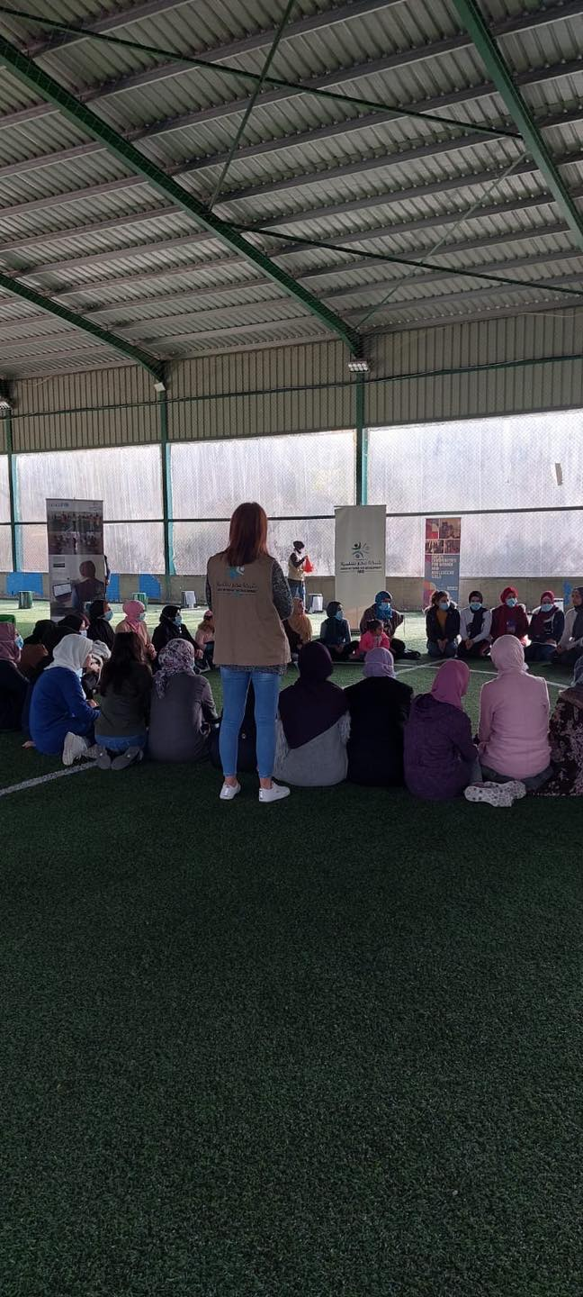

Personal voices, individual experiences are valued via Expressive Telling – Story examples

These stories are indicative, emerging from the two sides of this project, in Akkar with a mixed population of adults and some adolescents, mainly refugee Syrian, all respondents (identify as) female and secondly, other quotations from work in Tripoli with vulnerable youth, mixed gender groups.

Quotations from Participants in Expressive Writing and Telling Sept-Dec 2021
During Covid19 and socio-economic crises Lebanon, which joined the already-existing refugee crisis.

AHRC Project Expressive Writing and Telling in Crisis, Lebanon

From Shift International Tripoli (via Farah Sankari, implementer)
December 2021 on foot of first pilot with youth of the Expressive Writing and Telling Youth Curriculum

‘As promised please find below some quotes from various participants for your information and further use if needed. Please note that I have only used the initials of each participants as they did not feel confident sharing their information with a third party.

“following my participation in this curriculum I learnt that my life matter and some people are interested in listening to my story and together we could use to support other people” H.M; Jabal mehsen Leb. 17 years old Lebanese female.

“ having someone listen to what I am saying just for the sake of listening meant the world to me . I never knew I could matter to someone” M.b Tebbaneh 14 years old Lebanese male.

“this activity taught me how to look at things from different perspectives, it allowed me to highlight on my biggest fear , Identify different elements, dissect the problem and act accordingly. M.I kobbeh 16 years old Syrian female

“ for some reason I thought I can burry my fears and get over my worries without knowing that this will have repercussions on other members of my family. Participating in the expressive writing taught me how to identify the real challenge, address it in an efficient manner and find ways to overcome negative feelings” Zy. Kobbeh, Syrian male 12 years old.’

Akkar Network for Development NGO
From Implementation of Expressive Telling in Crisis, Sept to Dec 2021 and ongoing.
2 from ET in crisis, one older, one younger. 2 women, issues of food insecurity, commodity insecurity, domestic insecurity, lack of hope, stasis in crisis.
Names have been changed. DMP in place. Data securely stored by AND NGO, Akkar, partner to this project.
Expressive Telling – transcript of Maha’s story – as told to AND ( AA present, with NF oversight ) – Oct 2021
Section 1 and 2 – safety, privacy, covid safe arrangements in place. Consent provided.
Section 3. Results of ET 2 sessions, first and second session.

قباله
عمري 23 سنة. أنا من سوريا. أنا هنا في لبنان مع عائلتي بسبب الحرب. أنا
العيش مع زوج وثلاثة أطفال صغار في غرفة صغيرة في شمال لبنان. لن أقول أين.
هربنا من قريتنا بالقرب من حمص قبل 5 سنوات. لقد تزوجنا للتو منزلنا قد سوي بالأرض بالفعل اضطررت إلى العثور على عمل، كل ما يمكنني القيام به، لأن زوجي لا يستطيع العمل، لم يسمح له بالعمل. عملت في الحقول القريبة من قريتي، كان عملا شاقا. ظهري كان يؤلمني كان علي أن آخذ أحد الأطفال معي لعب الأطفال معا في الظل في زاوية الملعب.
عندما أتينا إلى لبنان، اعتقدت أن ذلك سيكون أفضل. الحكومة وعمال الإغاثة بذل قصارى جهدهم. لكن حياتي وحياة الأطفال قد تغيرت زوجي تغير لقد كان القائد والآن عليه أيضا أن يقف في طوابير للحصول على المياه والأدوية. لقد ضربني وهو ما لم يفعله في سوريا. إنه يصرخ أنا ملام على أشياء لا يمكن أن تكون غلطتي
كيف سنعود؟ حتى لو انتهت الحرب، لا يوجد شيء هناك بالنسبة لنا الآن. ولا يوجد شيء هنا بالنسبة لنا. هل يمكننا إطعام أطفالنا هنا بشكل أفضل مما هو عليه في سوريا؟ يجب أن نحصل على المساعدات التي تأتي يومين في الأسبوع. نذهب مع الجميع ونحصل على الحبوب والدقيق. أطفالي جائعون فقط في المساء حتى يشربوا بعض الماء ويذهبون إلى الفراش.
لا شيء سيكون كما كان كل شيء تغير

Maha
I am 23 years of age. I am from Syria. I am here in Lebanon with my family due to the war. I
live with husband and three small children in a small room in North Lebanon. I will not say where.
We fled our village near Homs 5 years ago. We had just been married. Our house had been flattened already. I had to find work, whatever I could do, because my husband could not work, was not allowed to work. I worked in the fields near my home village, it was hard work. My back was hurting. I had to take one of the children with me. The children played together in the shade in the corner of the field.
When we came here to Lebanon, I thought it would be better. The government and the aid workers do their best. But my life and the childrens’ life has changed. My husband has changed. He used to be the leader. Now he too has to queue for the water and medicines. He has hit me which he did not do in Syria. He shouts. I am blamed for things that cannot be my fault.
How will we ever go back? Even if the war ends, there is nothing there for us now. And there is nothing here for us. Can we feed our children here better than in Syria? We have to get the aid that comes two days in the week. We go with everyone else and we get the grain and the flour. My children are only hungry in the evenings so they drink some water and go to bed.
Nothing will be the same. Everything is changed.

Alina’s story – in ET (AA with NF) , all perms, consent, needs assessment in place, receiving level 4 follow up, social supports now in place for the children, children are now in school regularly.

ألينا هي جدة لثلاثة أعوام تبلغ من العمر 50 عاما. عاد ابنها، والد هؤلاء الأطفال، إلى سوريا قبل سبعة أشهر للانضمام إلى عائلته في محاولة لإعادة بناء منزلهم، لكنهم تعرضوا للقصف مرة أخرى، والآن لم تسمع منه شيئا. طلب منها أن تهتم بالأطفال حتى يأتي من أجلهم إنهم يعيشون في كوخ لا يوجد تدفئة. يحرقون ما يمكنهم الحصول عليه في الغابة من أجل الدفء. أعطيناهم بطانيات وأكياس نوم. ألينا يحاول القيام بعمل في بعض الأيام كعامل نظافة.
هذه قصتها: أنا وحيدة. لقد تطلقت منذ زمن بعيد ابنتي ماتت، أم هؤلاء الأطفال. كيف أعيش، كيف ليس لدي شيء. عليهم أن يساعدوني في تأمين الطعام والدواء. والدتهم لديها شهادة وفاة هذا يعني أن لدينا الأوراق للحصول على المساعدات ذهب ابني إلى سوريا في محاولة للعودة إلى هناك. ربما لم يتجاوز الحدود كان من الممكن أن يعتقل الناس يختفون أخي لم يسمع عنه أحد ابن أخي، واثنين من أبناء عمومة - الكثير من فقدت. لا أحد يعرف أين هم. هل سي شوهدوا مجددا؟ بلدنا أفضل من هذا. يمكن أن يكون أفضل مرة أخرى. لكنه ليس آمنا بعد لو كان آمنا لكان الأمر مختلفا سأبقى حتى أشعر أنها آمنة. لكن إذا جاء ابني، سأضطر للعودة معه ومع الأطفال. أريدهم أن يذهبوا إلى المدرسة هنا، لكن إذا كنت في العمل أو سأحصل على الأدوية، عليهم البقاء هنا، لا يمكنهم الخروج. أريدهم أن يتعلموا التعليم هو ما يمكن أن يغير الأشياء التي نراها، الأشياء التي نريد أن نكون مختلفين.

Alina is a 50 year-old grandmother of three. Her own son, the father of these children returned to Syria seven months ago to join in with his family to try and rebuild their house but they were bombed again and now she has not heard from him. He asked her to mind the children until he came for them. They live in a hut. There is no heating. They burn what they can get in the forest for warmth. We gave them blankets and sleeping bags. Alina tries to do work some days as a cleaner.
This is her story: I am alone. I divorced long ago. My daughter died, the mother of these children. How I am living, how I have nothing. They have to help me secure food and medicine. Their mother has a death certificate. This means we have the papers to get the aid. My son went to Syria to try for a return there. He may not have got past the border. He could have been arrested. People disappear. My brother has not been heard of. My nephew, and two of the cousins – so many lost. No one knows where they are. Will they ever be seen again? Our country is better than this. It could be better again. But it’s not safe yet. If it were safe, that would be different. I will stay until I feel it is safe. But if my son comes, I will have to go back with him and the children. I want them to go to school here but if I am at work or going to get the medicines, they have to stay here, they cannot go out. I want them to be educated. Education is what can change the things that we see, the things that we want to be different.

