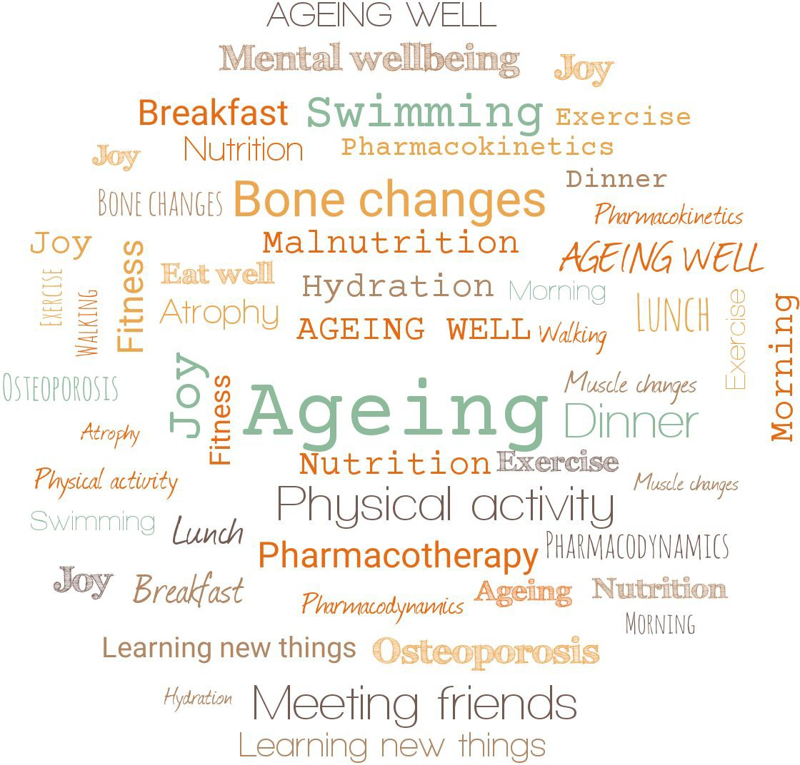

Ageing Well Public

Talk Series
2021/22

Series run Dr Jitka Vseteckova

School of Health, Wellbeing and Social Care Faculty of Wellbeing, Education and Language Studies

The Open University

Series 2021/22 - Talk 2 What do we need to know and do

to prepare for death and grief?

Dr Barbara Gale MBE, CEO St Nicholas Hospice Care @barbaragaleceo
School of Health, Wellbeing and Social Care Faculty of Wellbeing, Education and Language Studies
The Open University

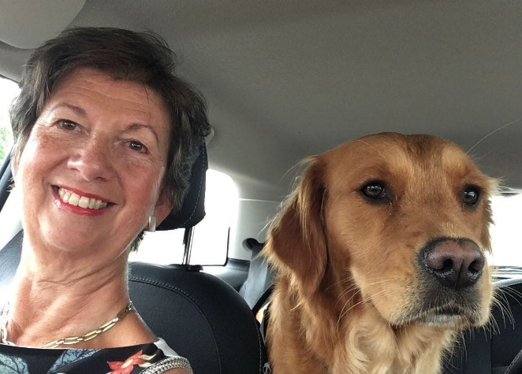
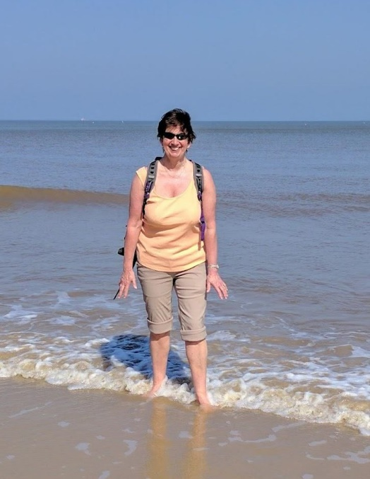
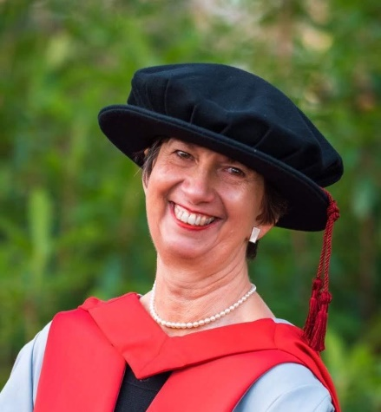
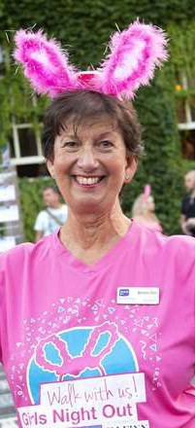
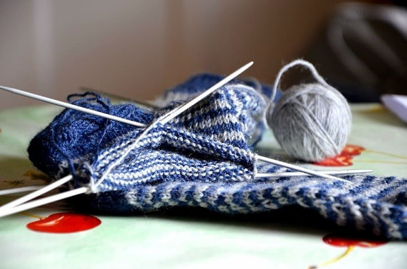

About me
Mother Grandmother
Dog lover, walker, reader, knitter! CEO
Learning - Masters x2, PhD - still learning..

Specialist palliative care, community, hospice, education, family therapist ,

My interest - dying death grief - everyone’s business

Preparing

Why don’t we talk about or prepare for death?

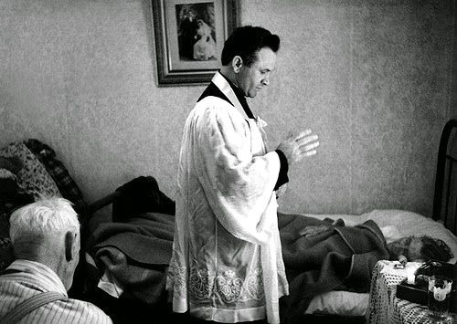
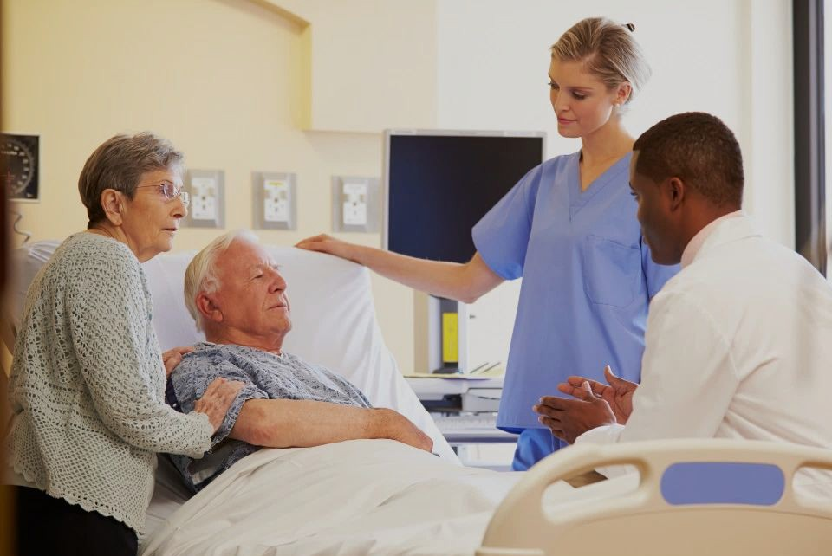

Death has changed from an event which is supported by your faith leader to one which is managed by healthcare professionals including hospices

Preparing for birth

- Learning -
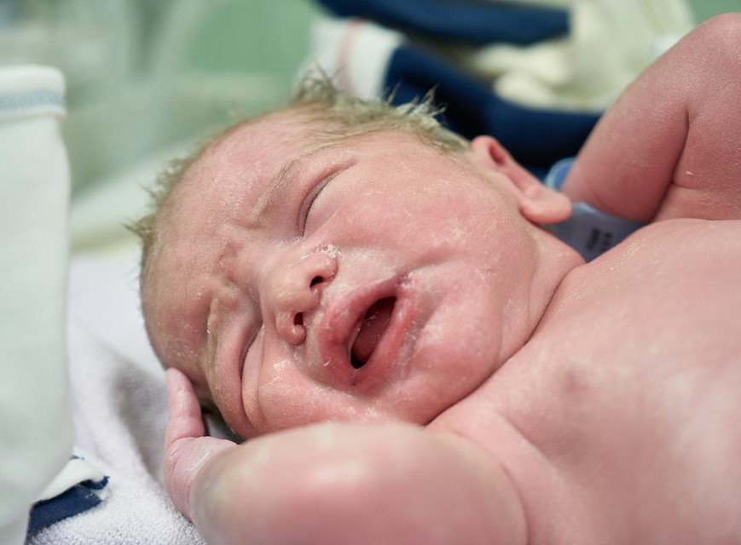
  - Understanding changes to your body, baby, birth stages
  - Professional roles, system
  - Books, video, classes, friends, mother
- Practical
  - Nursery, equipment, nappies, clothes, hospital bag, music, food
- Partner, support network
- Monitoring - midwife, obstetrician
- Decision plan and options

Knowledge
Facts
Community support
Practical skills
Experience
Learned wisdom
Hands on care Have the conversation
Practical help
Healthcare Legal Financial
Increasing our knowledge will enable us to take action to care for the dying and bereaved.

Practical checklist
- Equipment - bed, mattress, sheets, commode,
- Food - person and carer
- Support network
- Music, pictures
- Drugs - oral / injection / family trained
- Who’s who list and tel numbers
- Noonan, Horsfall, Leonard & Rosenberg (2016) -Developing death literacy, Progress in Palliative Care , 24:1, 31-35
- Information and clear guidance - what to expect
- Helpline numbers

Myths about talking or not talking...
Tempts fate Too upsetting
The professionals will let me know if I need to talk about it

I want to protect my family / children from being upset

National myth that we don’t talk about it

Treatment
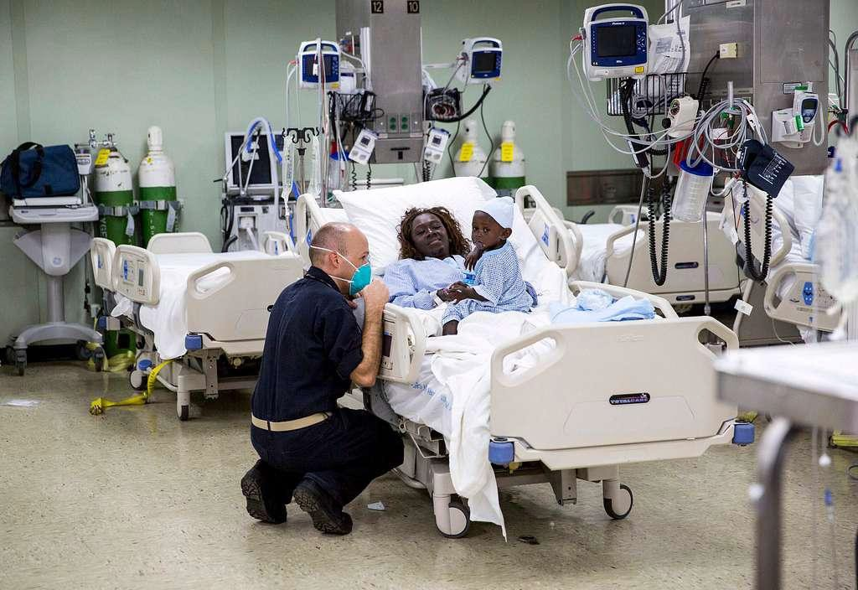At all costs? Better outcomes?

Resuscitation
Cardiopulmonary Resuscitation CPR It’s won’t always be ‘successful’
Right to refuse but not to demand (in UK)

Success rates vary from 17.5% down to less than 1% (survival to discharge from hospital). A lot of it depends on how ‘well’ you are in the moments just prior to your heart and breathing stopping.

Useful link: Talk CPR website

Questions to discuss with professionals

Your understanding of your illness? Your fears and worries for the future? Your goals if time is short?
What treatment or risks would be unacceptable to you?
What haven’t you asked they think you need to know?

Plans
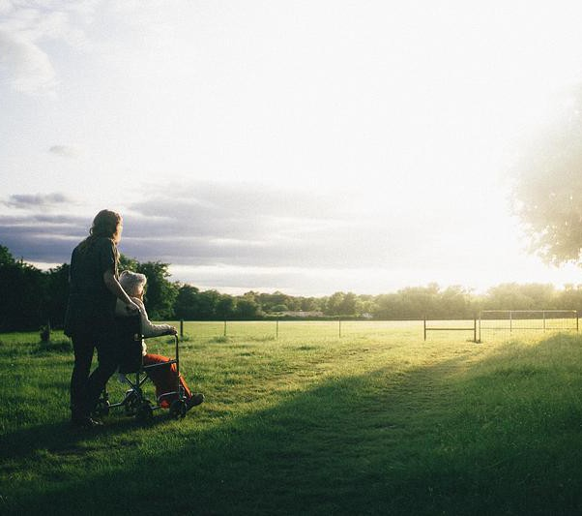Advance Care Plans are used to record your treatment and care wishes.

Advance Decision (Living Will) allows you to write down any treatments that you don’t want to have in the future, in case you later become unable to make or communicate decisions for yourself.

Lasting Power of Attorney (LPA) allows you to give someone you trust the legal power to make decisions on your behalf in case you later become unable to make decisions for yourself either (either health or finances)

Before I die I want to spend my time…...
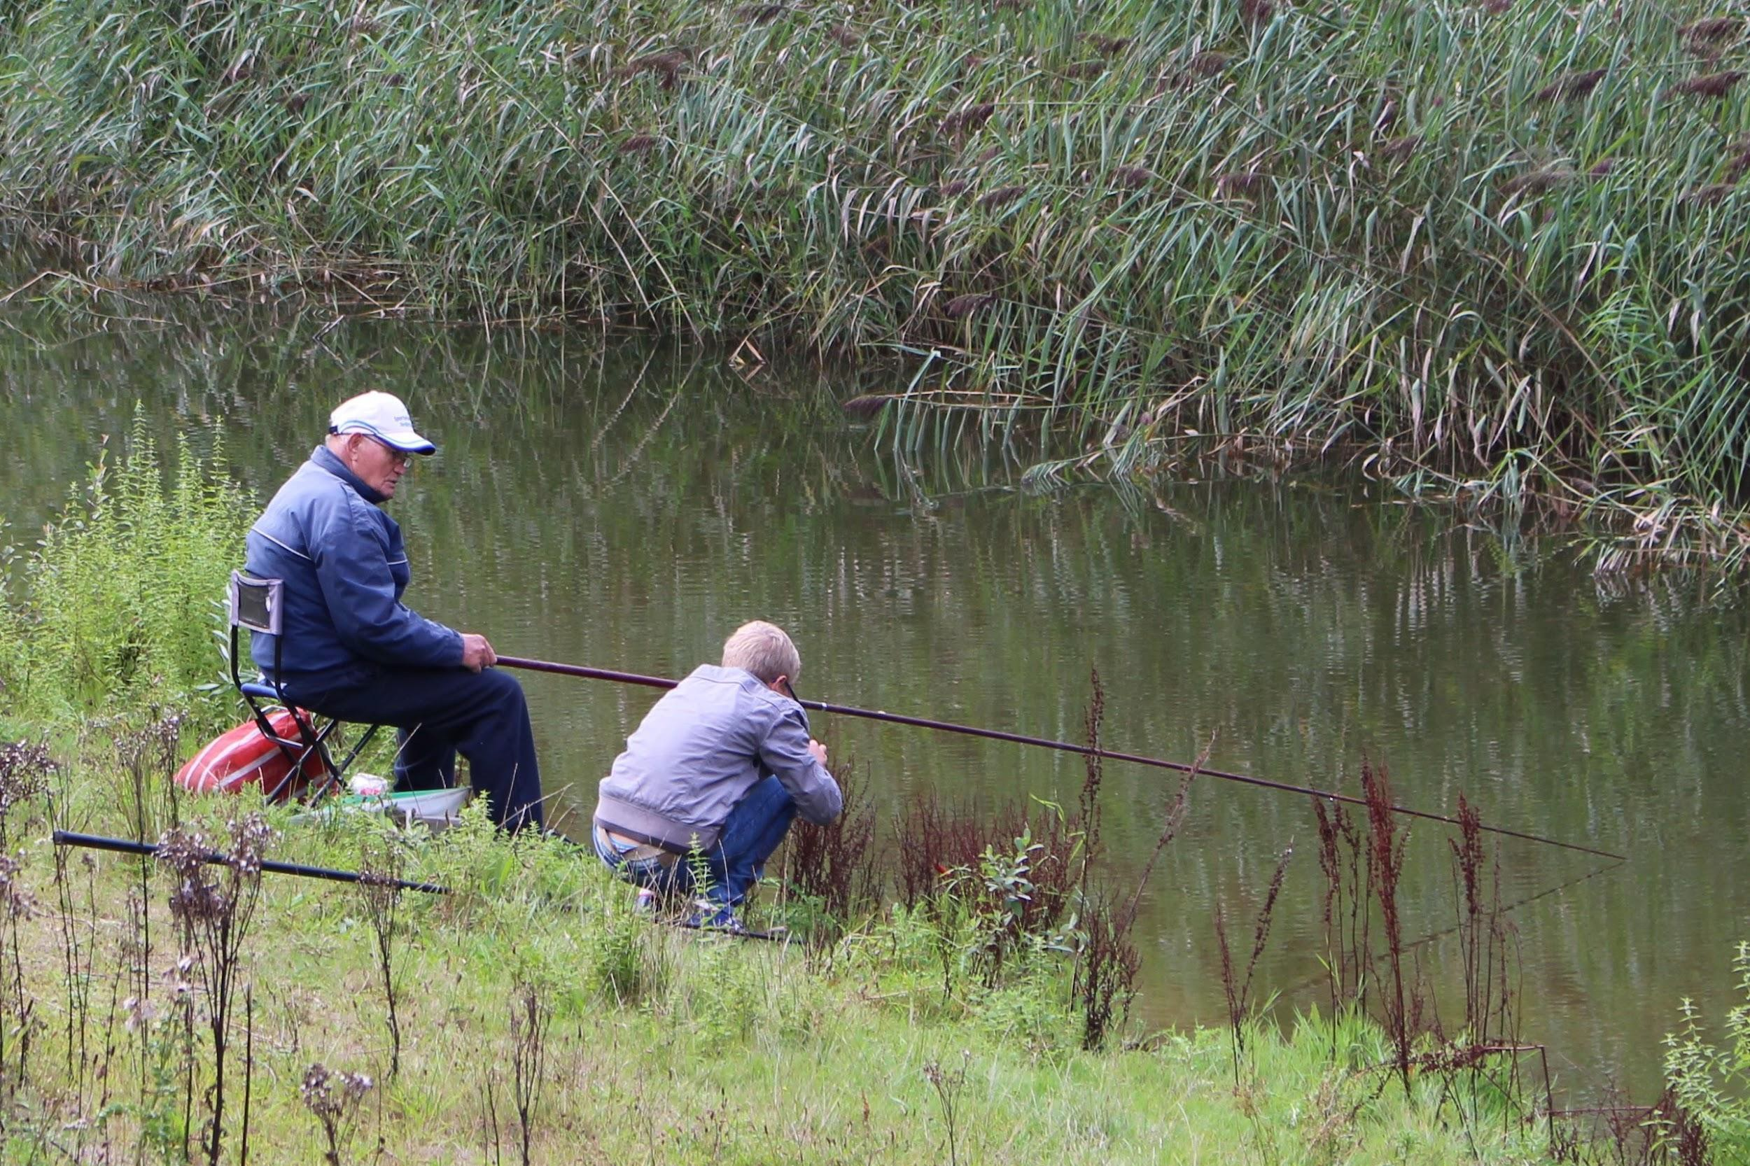
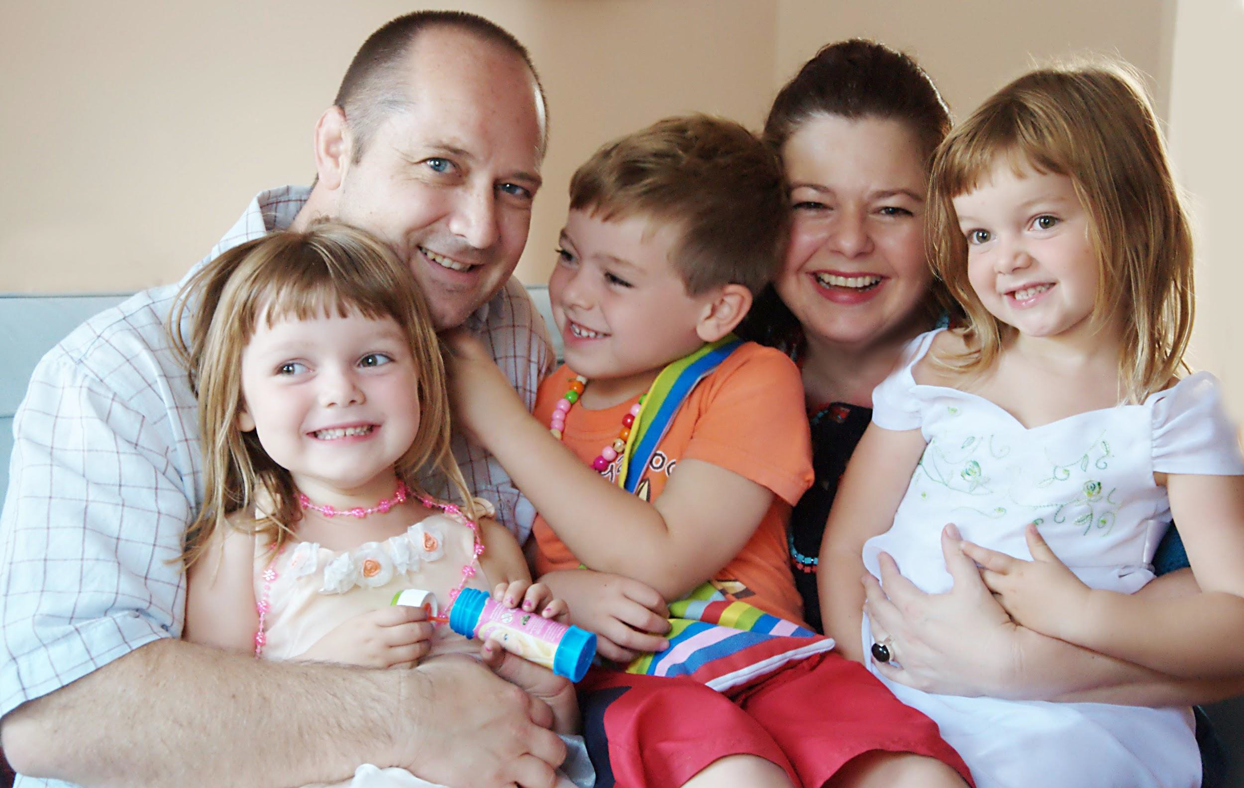
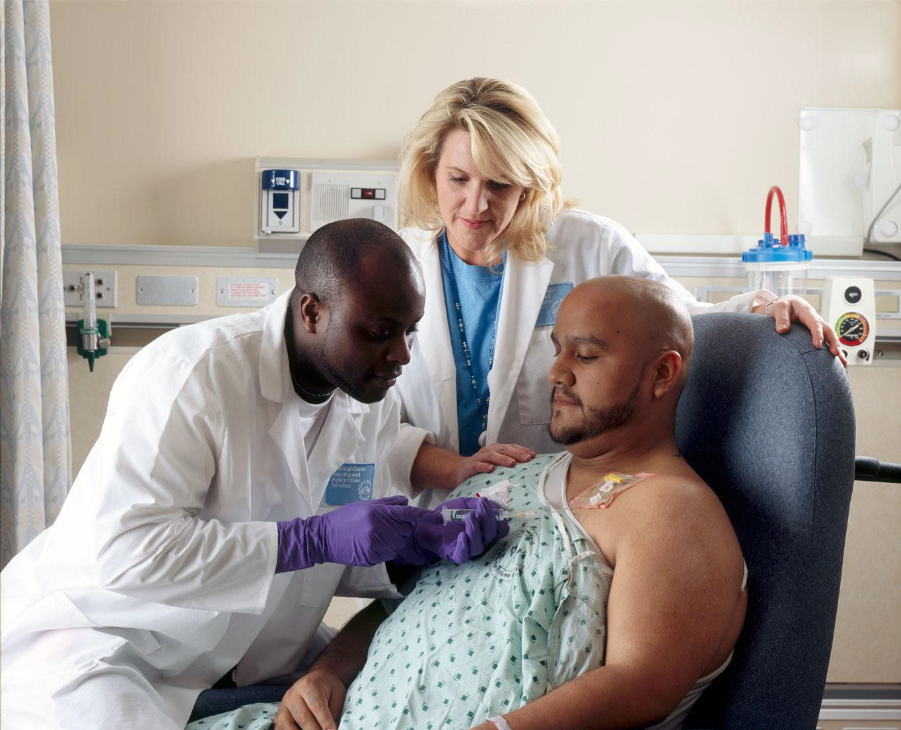
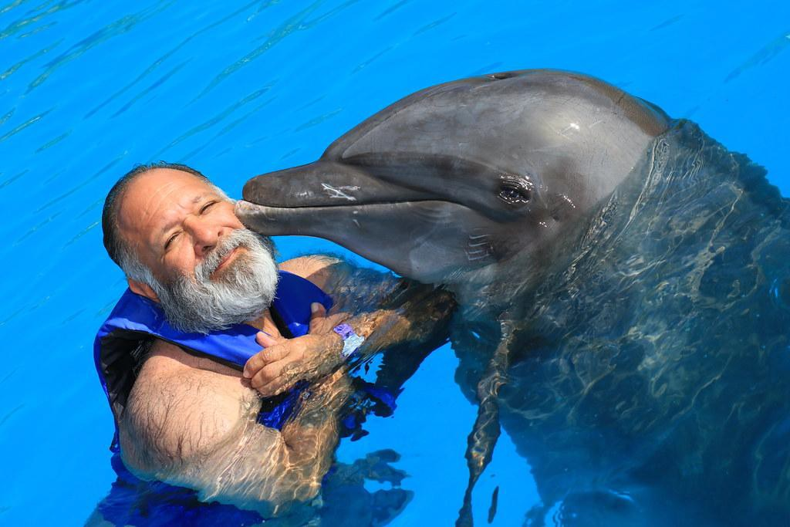
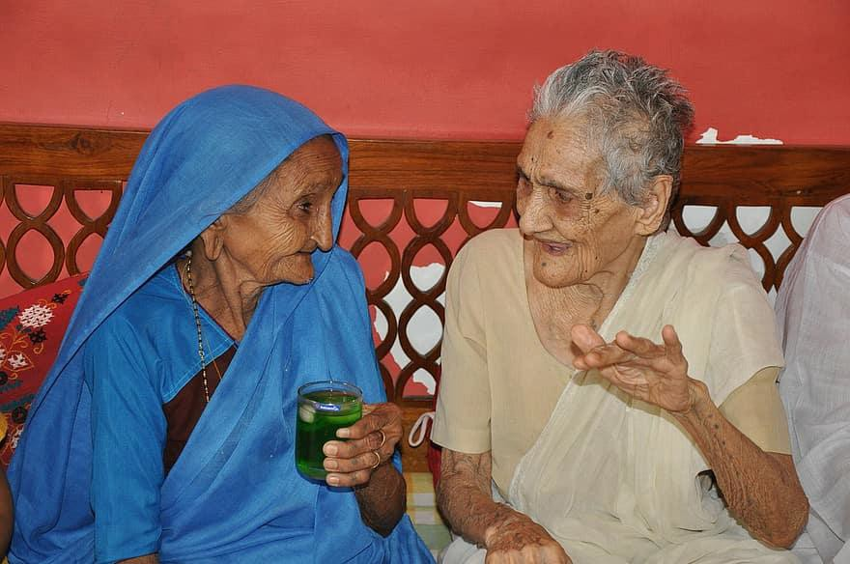

Last days
45% of us in England this will be our last view

23 % of us in England might be at home

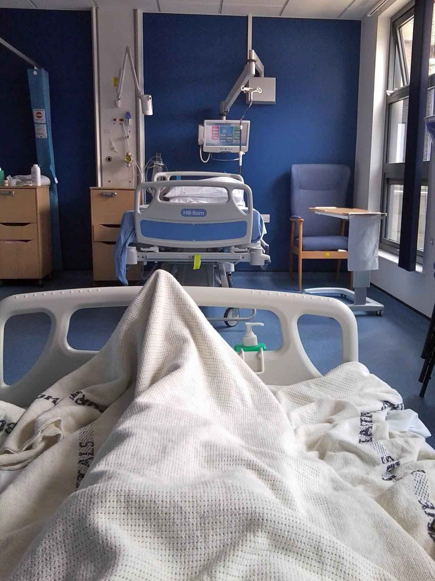

Where we die depends on the conversations we have and the plans we put in place

How do we prepare?

Financial / legal

- Pension
- Care costs
- Lasting Power of Attorney - Financial and Health
- Last Will and Testament
- Care - Advance Directive
- Digital - online, passwords

Wishes

- Funeral
- Bequests
- Care
- Momentos
- Letters
- Your legacy

If you do not make any plans for your digital estate, there may be items withheld from your loved ones or claimed by the online service provider. An executor using a password to access an account after a death may be guilty of a criminal offence under the Computer Misuse Act which was passed in 1990.

What is the dying process like?

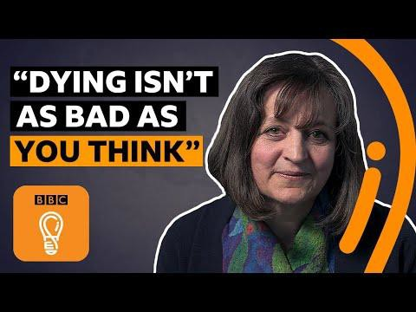
- Can happen anywhere

- People can still hear

- Saying last goodbye

- Last words

- Being present

'Dying is not as bad as you think' BBC Ideas https://youtu.be/CruBRZh8quc

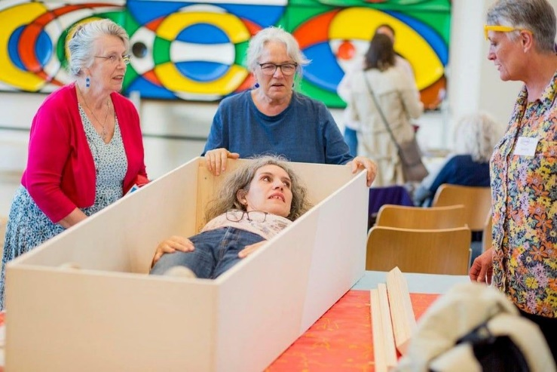
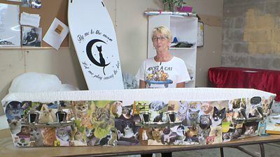
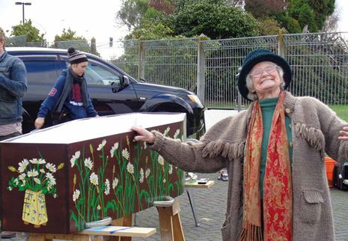
Funerals and myths
There is no legal requirement to use the services of a funeral director

Buy coﬃns online Funerals at home
You may bury a dead person on your own land (there are some restrictions)

The only legal requirement in the UK for funerals is that the death must be certiﬁed and registered, and the body must be disposed of.
Disposal means disposal by burial, cremation or any other means, and 'disposed of' has a corresponding meaning' - source Births and Deaths Registration Act, 1926.
London set to have its ﬁrst DIY 'Coﬃn Club' where members decorate their own caskets and discuss death over tea London Evening Standard

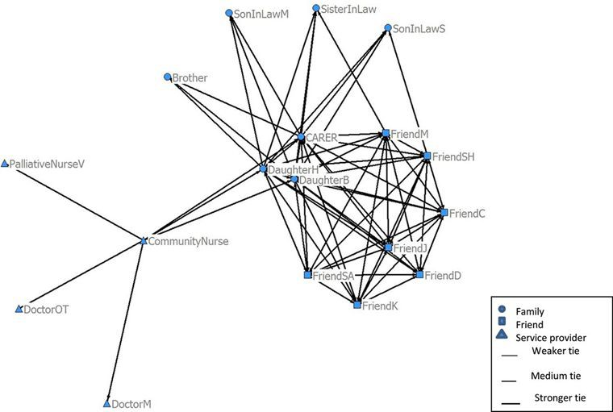Support networks

Spider diagram reference: Rosemary Leonard et al. BMJ Supportive and Palliative Care 2017
Horsfall, D., Yardley, A., Leonard, R., Noonan, K., & Rosenberg, J. P. (2015). End of Life at Home: Co-Creating an Ecology of Care

Support of friends and family

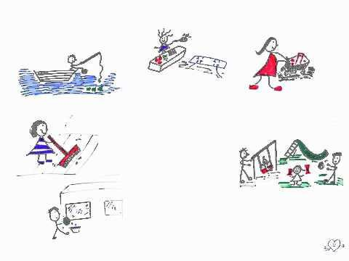

Bill's Story Let's Talk Series

Grief

  - Grief is different for everyone
  - Grief is not time limited
  - 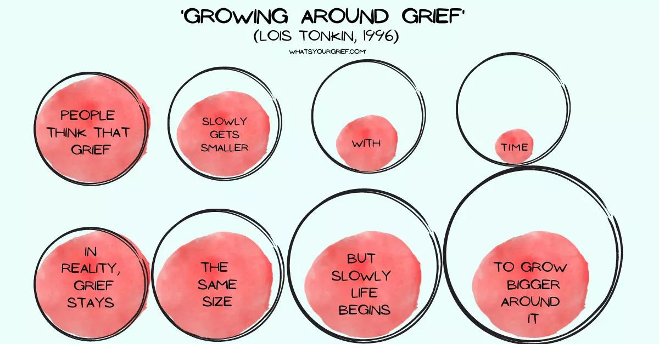It can come and go

Useful links include:
What’s your grief
Cruse Bereavement Support
Grief Chat

Ageing Well series of Public Talks - topics

- Are we prepared to live longer? (Jitka Vseteckova & Catherine Pestano) September 22 ^{nd} 2021
- Advanced care planning (Barbara Gale}

October 20 ^{th} 2021
- Ageing brain (Jitka Vseteckova & Marco Calabria} November 17th 2021

Learning languages and digital technologies in older age (Ursula Stickler) December 15 ^{th} 2021
- Disenfranchising grief and caring while ageing (Kerry Jones) January 19th 2022
- Nutritional needs while ageing (Jitka Vseteckova & Alan Hastings) February 23 ^{rd} 2022
- Pharmacotherapy while ageing (Jitka Vseteckova & Sonal Mehta) March 23rd 2022
- Mindfulness and ageing (Abi Methley) April 20 ^{th} 2022
- Move it and breathe (Jitka Vseteckova &
Declan Ryan) May 18th 2022
- Standing tall (Jitka Vseteckova) June 22 ^{nd} 2022
- The things we don't talk about- Intimacy and ageing (Andreas Vossler) July 20th 2022

Useful resources: Ageing Well Public Talks Series on ORDO

COMMUNFTIES

THANK YOU FOR SUPPORTING THE 'AGEING WELL PUBLIC TALK' SERIES
lL
"..'.:
f:'
s,,.,,;
Cf"
-i JI
t 11 J'. I
rh,11 n ,

