An Earth Anthem for the Covid-19 pandemic
Shonil Bhagwat, reveals the sense of nostalgia he feel when he recalls this Earth Anthem from the days of his environmental activism as a teenager – a sentiment, he says, that is not unfamiliar to many refugees and migrants who carry a nostalgia for their homeland which had so much to give.
When growing up as an environmentally conscious teenager in India in the 1990s, I came across a wonderful Earth anthem in Hindi which was popular among the environmental activist circles at that time. It has made a lasting impression on me. Rather than recording myself humming it (badly) to myself here is Amir V Kapoor singing part of Earth is Not a Day far better than I ever could [
Loosely translated in English, it goes something like this:
We have been a part of this Earth for eons and eons.
Bear in mind though that we have not inherited this Earth from our ancestors but borrowed it from our descendants to whom we are deeply indebted.
High mountains, fields and plains of this Earth, its rivers through which flows the elixir of life, all sing the song of life.
The cooling shade of its trees, which also bear flowers and fruits and shower them on us, have nurtured us.
Who knows how long have these trees lived on Earth? Who knows how many generations of people have been raised on this Earth?
For eons and eons, people have received a constant stream of pure love from Earth.
Let’s not forget that we will need to return the Earth to those from whom we have borrowed it.
We must remember that this not a gift from our forefathers, nor is it a luxury to be revelled in.
For me, this anthem means many things: It makes me feel nostalgic about the heady days of my environmental activism as a teenager. It reminds me that World Environment Day is more than just a day – it celebrates the people being part of this Earth for eons and eons. It makes me conscious that we need to think of our presence on Earth with a sense of responsibility and feel privileged that we have been able to borrow this Earth from our children, grandchildren and great grandchildren. It also makes me conscious that we should think of Earth with gratitude for the pure love we receive from the earth. This is the core theme of the World Environment Day.
The sense of nostalgia I feel when I remember this anthem is not unfamiliar to many refugees and migrants. This Earth anthem also captures that nostalgia of the homeland which had so much to give. As we think of the bounties of Earth, particularly during the Covid-19 lockdowns over the last year, this sense of nostalgia becomes even more acute. The high mountains or fields or plains in this anthem bring back the sense of being out in nature which we have missed so much during the lockdowns. It strongly resonates with the experiences of refugees and migrants who perhaps feel “trapped” whether in the refugee camps without being able to exercise their freedom of movement.
[Image: https://commons.wikimedia.org/wiki/File:Activities_for_world_environment_day_in_Bhopal_(2).jpg]
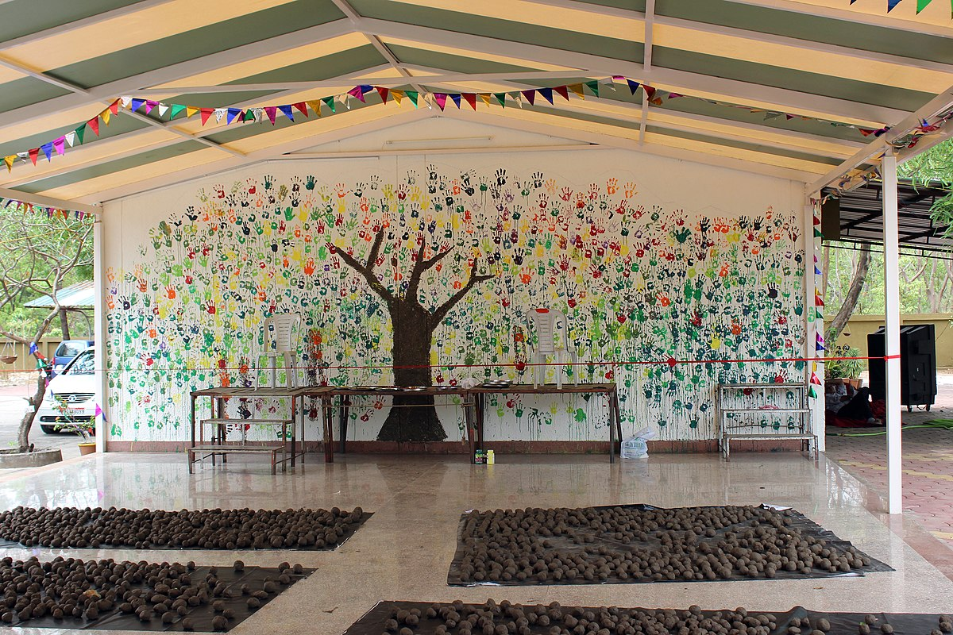
A world environment day mural in Bhopal, India
Suyash Dwivedi, Creative Commons Attribution-Share Alike 4.0 International license.
The World Environment Day can help of us to think of environmental concerns and the experiences of Covid-19 pandemic as connected. In the early days of the pandemic, international organisations were quick to point out that the emergence of SARS Cov-2 virus is strongly linked to environmental destruction, so the genesis of the pandemic itself is closely linked to our irresponsible relationship with the Earth. The anthem reminds us of our responsibilities towards the Earth when we enjoy our privileges. This is not dissimilar to the recent experiences of wearing masks in public places or social distancing measures that have become legal obligations so we can enjoy our freedoms during the Covid-19 pandemic. At an emotional level, this anthem points to the shared experiences of ordinary citizens who are left feeling a sense of confinement during Covid-19 lockdowns, just like many refugees and migrants may feel each day of their lives.
Another important point that this anthem makes is the issue of inter-generational justice. On this point, what is says is profound: we have not inherited this Earth from our forefathers (and mothers) but borrowed it from our children, grandchildren and great grandchildren – some of whom are yet to be born. How is it possible to borrow something from someone who is yet to be born? This is where the Earth anthem makes us acutely aware that our actions have consequences that go far beyond our own lifetimes and can have repercussions for generations that will come after we have left this Earth. This ‘reality check’ on the sense of responsibility is very important. It resonates with some of the discussions that have begun during the Covid-19 pandemic and the severity of illness and death rates among older age groups. Wearing of masks can prevent some transmission from asymptomatic carriers to those who are more vulnerable. This has thrown into sharp relief the responsibilities of a good mask-wearing citizen who keep their virus load to themselves as well as good vaccinated citizens who reduce the chances of severe illness.
[Image: https://commons.wikimedia.org/wiki/File:Covid-19_Vaccination_Centre_sign_in_Newbury,UK_2.jpg]
Covid-19 Vaccination Centre sign in Newbury,UK
KY CHOW, Creative Commons Attribution-Share Alike 4.0 International license.
This Earth anthem which originated in the environmental activist circles in the 1990s India endures even today. It has much to offer as we come to terms with the post-pandemic world and our responsibilities vis-à-vis privileges and rights. The Covid-19 pandemic has made us acutely aware that to enjoy our freedoms, we also need to take our responsibilities seriously. As we celebrate this World Environment Day, the anthem reminds us that Earth is more than just a day. It is about our long-term relationship with the Earth which has nurtured our many generations. The Covid-19 pandemic has thrown us out of our comfort zones, much like many refugees and migrants feel every day of their lives and have challenged out well-established ways of life. If we think of the environmental concerns and Covid-19 pandemic as closely connected, then we can start to take actions that protect our environment and make the world a better place.
Shonil Bhagwat is Professor of Environment and Development at The Open University

