“Nothing about me without me”
Breaking Down Barriers to Higher Education for Forced migrants

Lidia Dancu reports on how The Open University in Scotland is forging new partnerships with community organisations and opening up new opportunities with a “nothing about me without me” approach.
Although the Universal Declaration of Human Rights, Art 26 states that everyone has an equal right to education and that “higher education shall be equally accessible to all on the basis of merit”, the reality of accessing higher education is very different for displaced people. Forced migrants face innumerable barriers, including a lack of information, limited or no funding, inadequate language skills and training and, not least, how they are so frequently classified by the UK educational system as international students and required to pay international rate student fees. Libraries old and new for learning may therefore be out of the research of forced migrants wanting to study.

Image credit: Unsplash (Eugenio Mazzone)
According to the Refugee Agency (UNHCR), right now, only 3 percent of refugees have access to higher education, which has driven their commitment to ensuring that 15 percent of young refugee women and men can access the benefits of higher education by 2030. UNHCR’s education strategy aims to achieve this, by fostering the right conditions, collaborations and partnerships to allow those displaced to have equal and equitable access to education.
In the UK, most displaced people are classified as international students, thus putting access to colleges and universities out of their reach financially and deepening the social inequality between those born here and those who arrive seeking sanctuary. Even asylum- seeking children who have attended secondary school and college in the UK, are often treated as international students when applying to university, meaning that they are charged higher fees and have no right to work in the UK. Few are aware that eligibility to be treated as a ‘home’ student with home fee status is at the discretion of each individual institution. Whilst some universities have already made this positive move, many have not done so yet. The Universities of Sanctuary national network is campaigning to make this happen via dialogue, research and strategic efforts.
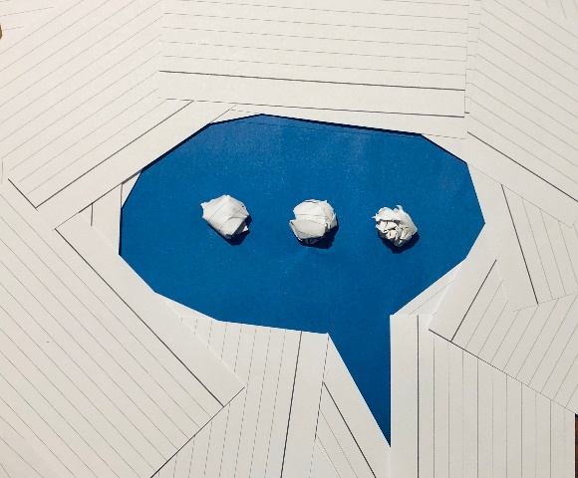
Image credit: Lidia Dancu
The Open University too is creating partnerships with community organisations to break down barriers to Higher Education for forced migrants and the OU in Scotland has been at the forefront of some very positive initiatives. For those of you who may be unaware of The Open University’s history and mission – its core aim is to be open to people, places, methods and ideas. It aims to promote educational opportunity and social justice, by providing high-quality university education to all who wish to realise their ambitions and fulfil their potential.
Forced migrants are not identified as a specific group targeted under OU widening access and participation objectives. However, they are located in groups that are. For example, many forced migrants live in low-income areas, share similar disadvantages to BAME groups as well as distinctive kinds of social injustice , have experienced trauma-related mental health issues or disabilities of various kinds. People who arrived in the UK as unaccompanied minors and granted status have also had experience of being in care (another criterion on inclusion in the target group) should also be included as beneficiaries of the OU’s widening participation and access programme. In sum, potential students from forced migrant backgrounds are likely to have at least one and often multiple characteristics of groups associated with under-representation in higher education.
In the spirit of ’nothing about me without me’, the Open University in Scotland’s approach has been to engage community organisations who have the knowledge, experience and can reach out to forced migrants. In a Covid world of physically distanced working relationships, these community partnerships are being achieved digitally.
A virtual roundtable event was held by OU in Scotland entitled: Open to People on 19 January 2021, to which forced migrants and all those working with them were invited to take part and share good practice and ideas for appropriate pathways into Higher Education for forced migrants. The aim of the event was to build and develop relationships between organisations working with forced migrants and the Open University in Scotland, by exploring ideas for collaboration and innovation. The event was organised by the Access, Participation and Success (APS) team at the OU in Scotland and it led with a power point presentation on the various widening access initiatives at the University, such as the Open Learn platform, English language provision, and resources co-created with refugees.
The roundtable discussions continued in breakout rooms where participants and OU staff discussed the learning needs and challenges of forced migrants and ideas for potential partnerships. In addition to the need for funding for scholarships, a number of other themes emerged during the discussions:
- English language skills and the need for better access to ESOL and IELTS resources.
- Extreme digital inequality and poverty, which affects many displaced people in Scotland in various ways, whether access to digital devices (laptops, tablets) or internet (wifi or data) or specific digital skills.
- Information about pathways into education and careers across the sector.
- Accreditation and recognition for professional experience and qualifications obtained in the country of origin which raises barrier to employment and to continuing educational aspirations.
- Clear information about credit transfer and accreditation, pathways into education, together with upskilling and employability projects could redress some of these imbalances.
- Academic and professional mentorship and one to one academic and pastoral support, which could go several steps closer to meeting the specific support needs of forced migrant learners.
- Specific support for forced migrant women who often have very specific issues which create disproportionate barriers to education: childcare and family commitments, lack of own funds, lack of language skills, lack of knowledge about available opportunities, lack of confidence, etc.

All in all, what emerged from the complex jigsaw of specific needs and barriers to education for forced migrants was a picture of lack of adequate resources and of inequality of opportunity. A picture which shapes a better understanding of the work which needs to be undertaken in partnership with community organisations to improve the educational and social justice outcomes for a section of our society who already face multiple deprivations. However, some ideas for how these could be addressed arose from the discussions, including:
- Employability courses with a content element (such as engineering, healthcare, hospitality, sciences) as well as an ESOL element to maintain learner’s motivation and prepare them for work in Scotland.
- Resources to support practitioners with advising those they work with about their rights and entitlements, and clear unambiguous guidance for forced migrants on issues such as funding entitlement, access to funding, immigration guidance, benefits.
- A universally recognised access course which would be accepted by other institutions at the point of entry.
- Tailored support to develop skills for online learning.

The Open University in Scotland is now exploring some of these ideas with other parts of the university, including the Open Justice Centre and the WELS faculty, and we hope to be able to progress them with partner organisations as part of our work to ensure that everyone has an equal opportunity to realise their ambitions and fulfil their potential. These projects will also support our progress towards becoming a University of Sanctuary.

January 31 2021

Lidia Dancu, Access, Participation and Success at the Open University in Scotland

Forced migrants are people who have been displaced from their countries of origin by war, lack of safety, and persecution and who are seeking sanctuary. An asylum seeker is a person who has applied for refugee protection and is waiting to be granted refugee status. A refugee is someone who the government has decided meets the criteria for a refugee according to the 1951 UN convention on Refugees.
Whilst the data on accommodation is not disaggregated by SIMD, this can be deduced from recent research undertaken by the Scottish Refugee Council (2019) which shows that most refugees accommodated in Glasgow City are in social housing types and areas associated with SIMD20 locations. https://www.scottishrefugeecouncil.org.uk/wp-content/uploads/2019/10/Navigating-the-maze-Refugee-routes-to-housing-support-and-settlement-in-Scotland.pdf
The majority of forced migrants in Scotland are from Black, Asian and Minority Ethnic communities (BAME), as indicated by the data sets in UK government data (2020) on asylum applications, initial decisions and resettlement. https://assets.publishing.service.gov.uk/government/uploads/system/uploads/attachment_data/file/910545/asylum-applications-datasets-jun-2020.xlsx
Many sanctuary seekers have a history of multiple traumas (see UoS resource pack p.24) https://universities.cityofsanctuary.org/wp-content/uploads/sites/68/2019/04/smaller-file-size-UOS-Resource-Pack-FINAL-12-SINGLE-PAGES-1.pdf
Celcis (2015). Supporting the education of looked after children with uncertain immigration status. https://www.celcis.org/files/8614/5019/7212/Uncertain_Imm_Status_in_template_FINAL.pdf

